Unit 3

Lesson 4 – PUPIL OF THE MONTH
- 1 a) Do you remember the boy in the picture?
What is his name?
Check the answer with your learning partner.
Sjećaš li se imena dječaka na slici?
Provjeri točnost odgovora s prijateljem iz klupe.

b) Listen to your teacher read the sentences.
Poslušaj svog učitelja kako čita rečenice.

1 Ollie is the star pupil this month. Ollie je najbolji učenik ovog mjeseca.

2 Both pupils and teachers like him.
Vole ga i učenici i učitelji.
c) Circle the correct answer.
Zaokruži točan odgovor.
1 Why is this month special for Ollie? Zašto je Olliju ovaj mjesec poseban?

A Ollie is the best player in his sports team.
Ollie je najbolji igrač u sportskom timu.

B Ollie is the star pupil this month.
Ollie je najbolji učenik mjeseca.

2 Who likes Ollie? Tko voli Ollija?

A Teachers like Ollie. B Pupils like Ollie.
Učitelji vole Ollija. Učenici vole Ollija.

C Both pupils and teacher like Ollie.
Ollija vole i učenici i učitelji.
2 a) Listen  to track 3.3 and find out more about Ollie. Poslušaj snimku 3.3 i saznaj nešto više o Olliju.


b) Read the following sentence with a help of your teacher.
Pročitaj rečenice uz pomoć svog učitelja.

1 Ollie is this month's star pupil.

Ollie je najbolji učenik ovog mjeseca.


2 He studies hard. 
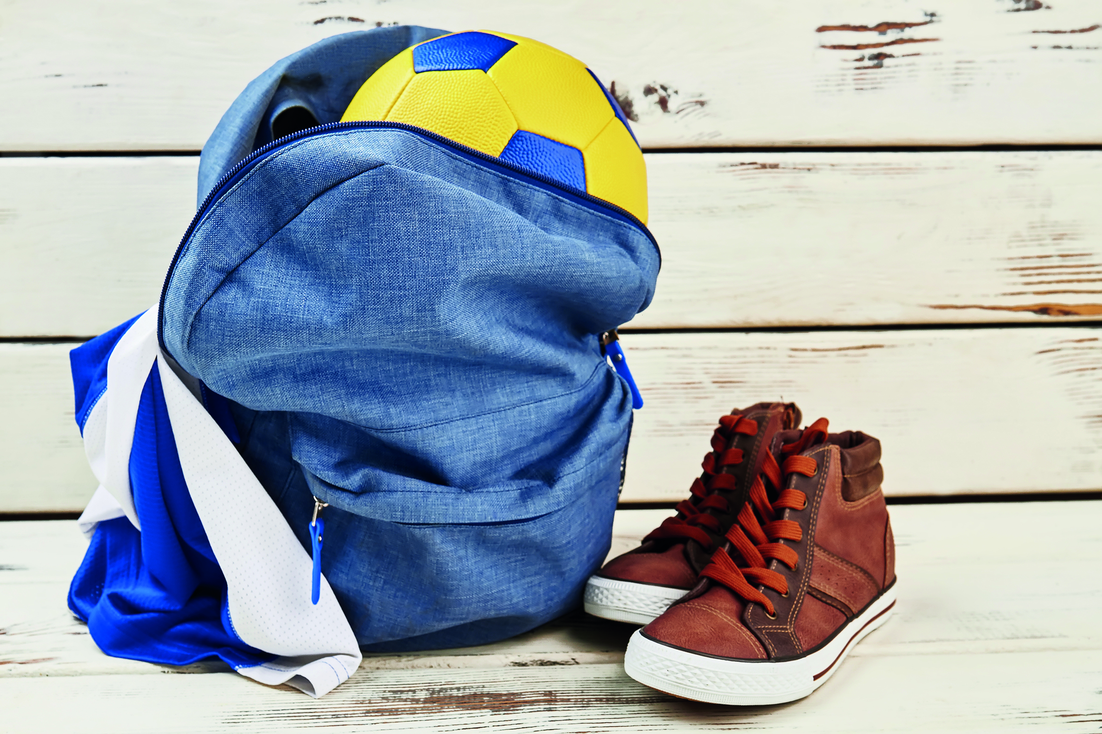 |  | 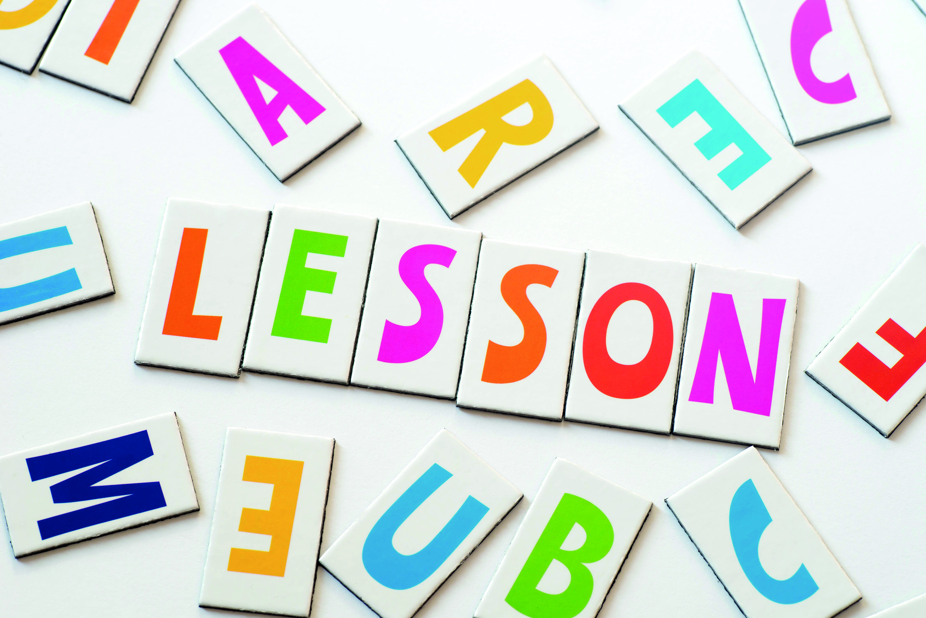 | 
 |  |  | 
 |  |  | 

On marljivo uči.

3 He is very good at most subjects.

On je vrlo dobar u većini predmeta.

 | 
4 He helps everyone.  On pomaže svima. | 5 He never gossips about other pupils.  On nikada ne ogovara / trača druge učenike.



6 Girls like him too because he never teases them.

Djevojčice ga vole jer ih nikada ne zadirkuje.




7 Ollie is not a bully.

Ollie nije nasilnik/ zlostavljač.

8 He doesn't fight with other children.

On se ne svađa s drugom djecom.

c) Read the sentences once again
and circle the words in bold.
Pročitaj rečenice još jednom. Zaokruži podebljane riječi.
d) Match the pictures to the words describing them.
Spoji slike s riječima koje ih opisuju.

e) Copy the words on the empty lines.
Write their and translatation in Croatian.
Find help in task 2 b).
Prepiši riječi na prazne crte. Prevedi ih na hrvatski.
Potraži pomoć u zadatku 2 b).
1  2 3 
a) bully
b) hardworking
c) tease
d) fight
e) help
f) star pupil
g) gossip
__________ ___________ _____________
__________ ___________ _____________

4  5 6  7
__________ _________ _________ _______________
__________ _________ _________ _______________

f) Work in pairs. Read the sentences.
Tick the ones that describe Ollie.
Rad u paru. Pročitajte rečenice.
Označite kvačicom one koje su istinite za Ollija.
1 He studies hard. 2 He helps his classmates. __
On marljivo uči. On pomaže svojim prijateljima iz razreda.

3 He chews gum in class. __ 4 He fights with other children. __
On žvače žvake u razredu. On se svađa s drugom djecom.

5 He gossips about other pupils. ____
On ogovara / trača ostale učenike.

6 He talks back. ____ 7 He tells lies. ____
On drsko odgovara. On priča laži.

8 He teases girls in class. ____
On zadirkuje djevojčice iz razreda.

g) Talk to your classmate.
Who are the best pupils in your class ?
Razgovaraj sa svojim prijateljem iz klupe.
Tko su najbolji učenici u tvom razredu?
1 Who studies hard?
Tko marljivo uči?
2 Who helps others?
Tko pomaže drugima?
3 Who is kind?
Tko je ljubazan?

h) Choose the words don't describe a star pupil.
Copy them on the empty lines.
Izaberi riječi koje ne opisuju najboljeg učenika i prepiši ih na prazne crte.
bully hardworking tease
fight help gossip

__________ ____________ ___________ ____________

i) Compare yourself to Ollie. Circle the correct answer.
Copy the sentence on the empty line.
Usporedi se s Ollijem. Zaokruži točan odgovor i prepiši ga na praznu crtu.
1 Ollie studieS hard. Do you?
Olli marljivo uči, a ti?

I study / don't study hard.
________________________________________________

2 Ollie helpS his classmates. Do you?
Ollie pomaže svojim prijateljima,a ti?

I help / don't help my classmates .
________________________________________________

j) Write down three (3) things that describe you.
Find help in task 2 a) or use expressions from the frame.
Kakav /kakva si ti? Napiši par rečenica o sebi.
Pomogni se rečenicama u zadatku 2 a) ili izrazima u okviru.
study hard / don't study hard tease/ don't tease
fight/ don't fight help/ don't help
gossip / don't gossip

I ________________________________________________ .
I ________________________________________________ .
I ________________________________________________ .

k) What about your friend?
Write down three (3) sentences about him / her.
Kakav je tvoj prijatelj / prijateljica. Napiši tri rečenice o njemu / njoj.
studies hard / doesn't study hard
teases/ doesn't tease fights/ doesn't fight
helps/ doesn't help gossips / doesn't gossip

He / she _______________________________________ .
He / she _______________________________________ .
He / she _______________________________________ .
- 3 a) Listen to track 3.4 and find out who is talking about Ollie.
Circle the correct answer.
Poslušaj zvučni zapis 3.4. i saznaj tko to priča o Olliju.
Zaokruži točan odgovor.

Q: Who is talking about Ollie? Tko priča o Olliju?

A Mr Black, Ollie's history teacher Gospodin Black, Ollijev učitelj povijesti.

B Mrs Brown, Ollie's maths teacher
Gospođa Brown, Ollijeva učiteljica matematike.

b) Listen to your teacher read about Ollie.
Underline the –s / -es endings in purple.

Poslušaj svog učitelja / učiteljicu kako čita o Olliju. Podcrtaj nastavke –s /-es u ljubičastom.

1 Ollie is hardworking and responsible.
Ollie je marljiv i odgovoran.

2 He always does his homework.
Ollie uvijek napravi domaću zadaću.
3 You can trust him because he doesn't tell lies.
U njega možeš imati povjerenja jer ne laže.

4 Ollie always listens to teachers. Ollie sluša učitelje.
5 He never talks in class.  On nikada ne priča tijekom sata. | 6 He learns a lot in class.  On puno nauči tijekom sata.
7 He is never rude.  On nikada nije bezobrazan. | 8 Ollie never talks back.  Ollie nikada drsko ne odgovara.
9 He never chews gum in class.  On nikada ne žvače žvaku na satu. | 10 He is kind and helpful.  On je ljubazan i voli pomagati.
11 He is just perfect.  On je jednostavno savršen. | 12 But he is sometimes late.  No, ponekad kasni na nastavu.

c) Circle the words that are true for Ollie.
Go back to task 3 b) and find the clues.
Zaokruži riječi koje su istinite za Ollija. Potraži pomoć u 3 c) zadatku.

great (izvrstan) handsome (zgodan)
rude (bezobrazan) chew gum ( žvakati žvakaću gumu)
kind (ljubazan) friendly (prijateljski raspoložen)

tall (visok) talk back ( drsko odgovarati)
lazy (lijen) hardworking (marljiv)
helpful (voli pomoći) responsible (odgovoran)
cruel (okrutan)

What do you like the best about Ollie? Write down three words about Ollie that you like the most.
Što ti se najviše sviđa kod Ollija? Napiši tri riječi koje ti se najviše sviđaju o Olliju.
_________________________ _______________________
_________________________

